Vehicle Management System

Business Scenario

Vehicle Management System is software which is helpful for bus operators, who wants to operate many bus trips in a day. In this software a person can be register as a user and he can manage the bus routes and the staff, passengers’ details. He can add a bus and its details including bus route details. User can also add the details of the staff and their duty time in the system.

Oracle Internal & Oracle University Use Only

There are mainly 5 modules in this software

* Bus Management
* Route Management
* Employee Management
* Passenger Management

In Bus module a user can add a new bus details to the database. He can set the details of the route and the timing also. Bus details like the type (air conditioned/non air conditioned/super deluxe), model number, seating capacity and the route in which the bus is going to be operated are added. Whenever the user wants to modify these details he can update new values through this software. Route Management module deals with the route management of the bus. A user can add the route and if he wants he can change it or delete that route. The main advantage is that this module is helpful for the agents to get details of the route and the details of the bus which have trip to that route. He can also get the information of the number of seats available in a particular day. Employee details of any bus can add to the database and this is helpful to the bus operators in the case of the salary and bates for the employee. An operator can add the personal details and if we want to edit or delete he can done modification using the Vehicle Management System. This is very helpful for the passenger also; if they have any complaint against staff he can approach the operator and easily identify the employee. Details of every passenger are stored in the system. A user can add a passenger only one time and if he came again operator can identify that person. Operator can add, edit and delete the details of the passenger.

Student has to create all the required tables that are mentioned in the problem statement and implement the application according to the business scenarios, the implementation details are mentioned in the Activities to be done by the student section.

Problem Statement Assumption

**2.1 Assumption**

System Analysis is a detailed study of the various operations performed by a system and their relationships within and outside of the system. Here the key question is- what all problems exist in the present system? What must be done to solve the problem? Analysis begins when a user or manager begins a study of the program using existing system.

During analysis, data collected on the various files, decision points and transactions handled by the present system. The commonly used tools in the system are Data Flow Diagram, interviews, etc. Training, experience and common sense are required for collection of relevant information needed to develop the system. The success of the system depends largely on how clearly the problem is defined, thoroughly investigated and properly carried out through the choice of solution. A good analysis model should provide not only the mechanisms of problem understanding but also the frame work of the solution. Thus it should be studied thoroughly by collecting data about the system. Then the proposed system should be analyzed thoroughly in accordance with the needs.

Oracle Internal & Oracle University Use Only

System analysis can be categorized into four parts.

* System planning and initial investigation
* Information Gathering
* Applying analysis tools for structured analysis
* Feasibility study
* Cost/ Benefit analysis

In the existing system all the jobs of the bus route management is done manually. This is very difficult to the operators who want to handle hundreds of trips and many buses in a day. The currents system is that an operator wants to keep the physical records of the bus route in his office and a separate record for the passengers’ and for the booked seats. In current system there is no way to store the details of the employees’ working in the bus. So many complaints against staff can arise from the passengers’ side. More over there is no detailed record of the bus and routes in which they service

So this system is very useful for the operators and passengers. This avoids the overheads for the operators. They can minimize the working stress and can keep essential documents related to the bus and the passengers as a softcopy. The advantage of the system is the reduction in the cost of the office equipments and the transaction is done quickly. Any operator can answer if any seats for a particular route in a particular day are available or not.

Our system has several advantages

* User friendly interface
* Fast access to database
* Less error
* More Storage Capacity
* Search facility
* Look and Feel Environment
* Quick transaction

2.2 DATA FLOW DIAGRAM (DFD)

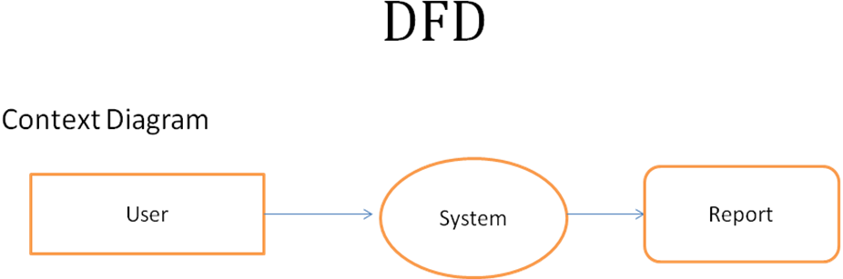

Oracle Internal & Oracle University Use Only

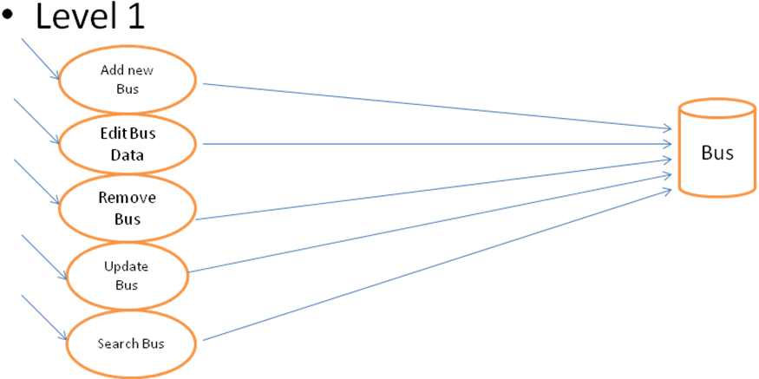

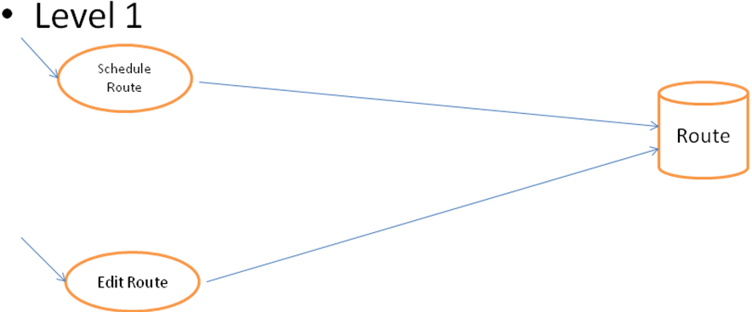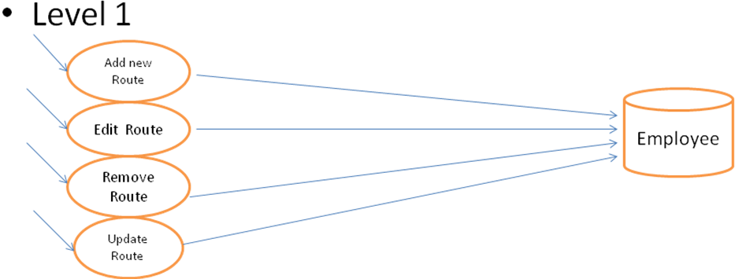

Oracle Internal & Oracle University Use Only

Tools to be used:

* Oracle 10g Database
* JDK 1.7
* Eclipse IDE
* Angular 4

Activities to be done by the students

**5.1 DATABASE DESIGN**

The general theme behind a database is to handle information as an integrated whole. A database is a collection of interrelated data stored with minimum redundancy to serve many users quickly and effectively. After designing input and output, the analyst must concentrate on database design or how data should be organized around user requirements. The general objective is to make information access, easy quick, inexpensive and flexible for other users. During database design the following objectives are concerned:-

Oracle Internal & Oracle University Use Only

* Controlled Redundancy
* Data independence
* Accurate and integrating
* More information at low cost
* Recovery from failure
* Privacy and security
* Performance
* Ease of learning and use

**5.2 Entities**

* Users
* Booking
* Buses
* Employee
* Passenger

Oracle Internal & Oracle University Use Only

* Payment
* Route
* Schedules
* Trips
* Validator

Note: Ensure that primary key constraint is given for all the tables

After creating the tables and their relationships they have to store some records to each table (at least 5 records).

Student are going to create lot of web pages here, firstly they have to configure an home page for the application so that as soon as they access the application through an URL it should show this home page, the home page will have following components

* A heading at the top which displays the Welcome to Samiksha Travels and footer at the bottom of the page, heading and footer should appear on all other pages the user visits.
* Below the heading a common navigation links like **Home, Login, About us and Contact Us.** These navigation links should appear on all other pages the user visits.
* A section that will show some images(width and height of the images should be small) which would be randomly changing these images can be for advertisements like some discounts the traveling provides on festivals, older people above 60, types of buses they are providing and etc.
* When user clicks on the login link a login page should be displayed which should take username and password

If the user clicks on the Login link then the application should render a login page and should do the following

* The login page should ask a user to enter username, password and type of login as Admin, Booking Clerk and Driver and passenger.
* If user logs in as Admin he/she can
* add employee details
* delete employee details
* display all employee details (Here the employees are Booking Clerk/Driver).
* see all the booked ticket details by all the passengers
* If user login as Booking Clerk he/she can:
* see his own profile details.
* can update his/her own profile
* add Driver details.
* add new Bus details like BusNumber, RegNumber, Model, Seating Capacity, Date Purchased, Insurance Status, Date insured, Insurance expiry date and etc.
* Update the existing bus details.
* add new bus route details like RouteNumber, RouteName, From, To, Distance, Fare etc

Oracle Internal & Oracle University Use Only

* For existing buses update the new route like change from and to, fare, Distance etc.
* Generate All Bus reports as well as Booking Reports etc
* If user login as Driver he/she can
* See his/her own profile details.
* update his/her own profile
* See his/her bus and route details allocated by the Clerk.
* If user login as Passenger he/she can
* See his/her own profile details.
* update his/her own profile
* Book the bus by selecting the route name, seats, date and payment.
* Cancel the booked bus ticket.
* Update the date and seats and route name for already booked ticket.
* If login information is correct then the application should direct him to the success page by checking from the database table **Employee**, else an error message should be displayed saying invalid credentials and should allow him to login again by asking username and password below the error message. To check username and password use the DAO

**Note:**

1. Students should follow MVC design pattern while create this application.
2. Students should use DAO whenever they have to execute any business logics
3. Students has to use java beans and DAO whenever they found some values/object properties should be checked in the database and pass the values/objects to another page or when the values has to be reused, store the records to the proper columns and tables.
4. For views students can use HTML/CSS/XHTML/JSP/JSF.
5. For controller students can use Servlets
6. For model students can use Java beans/Managed beans/POJO
7. For database logics students can use JPA/JDBC

Guidelines to the instructors

**Step 1**

After teaching them the HTML, CSS, JavaScript, SQL/PLSQL, Java, JDBC and JEE. Let student create all the required tables for the project. It might go in cycle and the facilitator helps the participants to design tables by giving the comments and feedbacks.

Oracle Internal & Oracle University Use Only

**Step 2**

Once the basic design is approved by the facilitator, the team can go ahead and create a web project in IDE, components to be monitored

* Creation of Tables and constraints
* Inserting the records to the table
* Designing View components
* Navigating from one view to another
* Creating Java Beans and DAO for the database tables
* Reading the user data and rendering the proper View
* Input Validation

**Step 3** – Role Play

* Let the team present their project.
* Note Down comments/ideas by other team and facilitator
* Keeping these ideas as base, team has to list down the queries that can facilitate the departmental store.

**Step 4** – Validate

All learning objectives defined above for the project should have been met. If not revisit and ensure the learning objectives are met for the project

**Step 5** - Extension of Project work

Generate the bus route reports

1. date wise
2. route wise
3. distance wise
4. type of buses (AC/Non-AC)

If passenger cancels the ticket refund amount must follow below rules

1. before 24 hours of travelling 5 % deduction
2. before 12 hours of travelling 10% deduction
3. before 6 hours of travelling 20% deduction
4. before 3 hours of travelling 30% deduction
5. before 1 hour of travelling 80% deduction

**Step 6** – Pre Assessment and Post Assessment during the workshop

Reference Material

Oracle Internal & Oracle University Use Only

* Java Documentation :

<http://docs.oracle.com/javase/tutorial/>

* Java EE Documentation :

<http://docs.oracle.com/javaee/7/tutorial/>